**ASSIGNMENT 1 FRONT SHEET**

|  |  |  |  |
| --- | --- | --- | --- |
| **Qualification** | **BTEC Level 5 HND Diploma in Computing** | | |
| **Unit number and title** | Unit 2: Networking Infrastructure | | |
| **Submission date** | August 8th 2022 | **Date Received 1st submission** |  |
| **Re-submission Date** |  | **Date Received 2nd submission** |  |
| **Student Name** | Ly Thanh Hao | **Student ID** | GCC210232 |
| **Class** | GCC1001 | **Assessor name** | Le Huynh Quoc Bao |
| **Student declaration**  I certify that the assignment submission is entirely my own work and I fully understand the consequences of plagiarism. I understand that making a false declaration is a form of malpractice. | | | |
|  |  | **Student’s signature** |  |

**Grading grid**

|  |  |  |  |  |  |  |
| --- | --- | --- | --- | --- | --- | --- |
| P1 | P2 | P3 | P4 | M1 | M2 | D1 |
|  |  |  |  |  |  |  |

|  |  |  |
| --- | --- | --- |
| **❒ Summative Feedback: ❒ Resubmission Feedback:** | | |
| **Grade:** | **Assessor Signature:** | **Date:** |
| **Lecturer Signature:** | | |

**Table of Contents**

1. Task 1 - Discuss the benefits and constraints of different network types and standards (P1) 4

1.1. Network 4

1.1.1. What is network? 4

1.1.2. Some common types of networks: 4

1.2. Network protocol 8

1.2.1. What is Network protocol? 8

1.2.2. What is the purpose of the network protocol? 9

1.2.3. Some common protocols 9

1.3. International standard organizations 14

1.3.1. ISO 14

1.3.2. IEEE 14

1.3.3. W3C 14

2. Task 2 - Explain the impact of network topology, communication and bandwidth requirements (P2) 15

2.1. Network topology 15

2.1.1. Definition of network topology 15

2.1.2. Physical topology 15

2.1.3. Logical topology 15

2.1.4. The difference between physical topology and logical topology. 16

2.1.5. Examples of popular topologies 17

2.1.6. Communication network 23

2.1.7. The rules in the network 24

2.1.8. Why are these rules needed? 24

2.2. Bandwidth requirements 25

2.2.1. Why is bandwidth requirement needed for networks? 25

3. Task 3 - Discuss the operating principles of networking devices and server types (P3) 26

3.1. How some devices work in the network? 26

3.1.1. Switches 26

3.1.2. Router 26

3.2. Some other common networking devices 27

3.2.1. Gateway 27

3.2.2. Firewall 27

3.2.3. Access point 28

3.3. Some common types of servers 28

3.3.1. DNS sever 28

3.3.2. Web sever 30

3.3.3. FPT sever 31

4. Task 4 - Discuss the inter-dependence of workstation hardware with relevant networking software (P4) 32

4.1. What does Interdependence mean? 32

4.2. Workstation hardware 33

4.3. Networking software 34

4.4. The interdependence of workstation hardware and network software: 35

5. References 36

# Task 1 - Discuss the benefits and constraints of different network types and standards (P1)

## Network

### What is network?

A **Computer Network** is a group of two or more interconnected computer systems that use common connection protocols for sharing various resources and files. You can establish a computer network connection using either cable or wireless media. Every network involves hardware and software that connects computers and tools. **(Williams, 2022)**

### Some common types of networks:

#### What is LAN?

A **Local Area Network** (LAN) is a group of computer and peripheral devices which are connected in a limited area such as school, laboratory, home, and office building. It is a widely useful network for sharing resources like files, printers, games, and other application. The simplest type of LAN network is to connect computers and a printer in someone’s home or office. In general, LAN will be used as one type of transmission medium. It is a network which consists of less than 5000 interconnected devices across several buildings. **(Williams, 2022)**

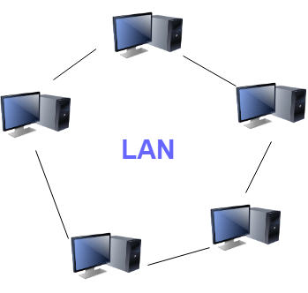

**(Williams, 2022)**

* **Advantage of LAN**
* Computer resources like hard-disks, DVD-ROM, and printers can share local area networks. This significantly reduces the cost of hardware purchases.
* You can use the same software over the network instead of purchasing the licensed software for each client in the network.
* Data of all network users can be stored on a single hard disk of the server computer.
* You can easily transfer data and messages over networked computers.
* It will be easy to manage data at only one place, which makes data more secure.
* Local Area Network offers the facility to share a single internet connection among all the LAN users. **(Williams, 2022)**
* **Disadvantage of LAN**
* LAN will indeed save cost because of shared computer resources, but the initial cost of installing Local Area Networks is quite high.
* The LAN admin can check personal data files of every LAN user, so it does not offer good privacy.
* Unauthorized users can access critical data of an organization in case LAN admin is not able to secure centralized data repository.
* Local Area Network requires a constant LAN administration as there are issues related to software setup and hardware failures **(Williams, 2022)**

#### What is WAN?

WAN or Wide Area Network is a computer network that extends over a large geographical area, although it might be confined within the bounds of a state or country. A WAN could be a connection of LAN connecting to other LANs via telephone lines and radio waves and may be limited to an enterprise (a corporation or an organization) or accessible to the public. The technology is high speed and relatively expensive. **(Goyal, 2021)**

* **Advantage of WAN**
* **Geographical area:** A Wide Area Network provides a large geographical area. Suppose if the branch of our office is in a different city then we can connect with them through WAN. The internet provides a leased line through which we can connect with another branch.
* **Centralized data:** In case of WAN network, data is centralized. Therefore, we do not need to buy the emails, files or back up servers.
* **Get updated files:** Software companies work on the live server. Therefore, the programmers get the updated files within seconds.
* **Exchange messages:** In a WAN network, messages are transmitted fast. The web application like Facebook, Whatsapp, Skype allows you to communicate with friends.
* **Sharing of software and resources:** In WAN network, we can share the software and other resources like a hard drive, RAM.
* **Global business:** We can do the business over the internet globally.
* **High bandwidth:** If we use the leased lines for our company then this gives the high bandwidth. The high bandwidth increases the data transfer rate which in turn increases the productivity of our company. (JavaTpoint, 2021)
* **Disadvantage of WAN**
* **Security issue:**A WAN network has more security issues as compared to LAN and MAN network as all the technologies are combined together that creates the security problem.
* **Needs Firewall & antivirus software:**The data is transferred on the internet which can be changed or hacked by the hackers, so the firewall needs to be used. Some people can inject the virus in our system so antivirus is needed to protect from such a virus.
* **High Setup cost:**An installation cost of the WAN network is high as it involves the purchasing of routers, switches.
* **Troubleshooting problems:** It covers a large area so fixing the problem is difficult.

**(JavaTpoint, 2021)**

#### What is PAN?

* Personal Area Network is a network arranged within an individual person, typically within a range of 10 meters.
* Personal Area Network is used for connecting the computer devices of personal use is known as Personal Area Network.
* Thomas Zimmerman was the first research scientist to bring the idea of the Personal Area Network.
* Personal Area Network covers an area of 30 feet.
* Personal computer devices that are used to develop the personal area network are the laptop, mobile phones, media player and play stations. **(JavaTpoint, 2021)**

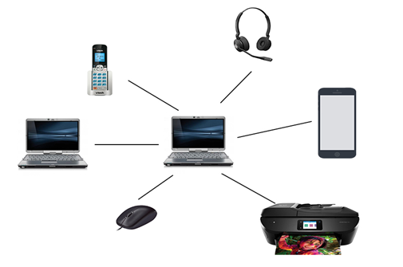

**(JavaTpoint, 2021)**

* **Advantage of PAN**
* PAN is relatively flexible and provides high efficiency for short network ranges.
* It needs easy setup and relatively low cost.
* It does not require frequent installations and maintenance
* It is easy and portable.
* Needs fewer technical skills to use. **(Satyabrata_Jena, 2022)**
* **Disadvantage of PAN**
* Low network coverage area/range.
* Limited to relatively low data rates.
* Devices are not compatible with each other.
* Inbuilt WPAN devices are a little bit costly. **(Satyabrata_Jena, 2022)**

#### What is MAN?

MAN or Metropolitan area Network covers a larger area than that of a LAN and smaller area as compared to WAN. It connects two or more computers that are apart but reside in the same or different cities. It covers a large geographical area and may serve as an ISP (Internet Service Provider). MAN is designed for customers who need high-speed connectivity. Speeds of MAN range in terms of Mbps. It’s hard to design and maintain a Metropolitan Area Network. **(Goyal, 2021)**

* **Advantage of MAN**
* It offers fast communication using high-speed carriers, like [fiber optic cables](https://www.guru99.com/ethernet-cables-types.html).
* It provides excellent support for an extensive size network and greater access to WANs.
* The dual bus in MAN network provides support to transmit data in both directions concurrently.
* A MAN network mostly includes some areas of a city or an entire city. **(Williams, 2022)**
* **Disadvantage of MAN**
* You need more cable to establish MAN connection from one place to another.
* In MAN network it is tough to make the system secure from hackers **(Williams, 2022)**

## Network protocol

### What is Network protocol?

A network protocol is an established set of rules that determine how data is transmitted between different devices in the same network. Essentially, it allows connected devices to communicate with each other, regardless of any differences in their internal processes, structure or design. Network protocols are the reason you can easily communicate with people all over the world, and thus play a critical role in modern digital communications. **(CompTIA, 2021)**

### What is the purpose of the network protocol?

Similar to the way that speaking the same language simplifies communication between two people, network protocols make it possible for devices to interact with each other because of predetermined rules built into devices’ software and hardware. Neither [local area networks (LAN)](https://www.comptia.org/content/guides/what-is-a-local-area-network) nor [wide area networks (WAN)](https://www.comptia.org/content/guides/what-is-a-wide-area-network) could function the way they do today without the use of network protocols. **(CompTIA, 2021)**

### Some common protocols

#### TCP

The Transmission Control Protocol (TCP) is a standard that defines how to establish and maintain a network connection through which application programs can exchange data. It is used on the top of IP to provide reliable transmission of packets.

TCP is a connection-oriented reliable protocol. Two devices need to establish a connection before start using TCP and sending the data. It also provides an acknowledgment to the sender device regarding the status of the data being sent.

**(Datta, 2021)**

#### IP

Standardized by IEEE in 1974, this protocol is responsible for addressing and [fragmenting](https://en.wikipedia.org/wiki/Fragmentation_(computing)) data packets in digital networks. Its goal is to ensure the successful delivery of packets from source to destination. For this purpose, the IP specifies a format that defines the type of description of data packets called IP datagrams.

The first major version of IP is IPv4, and it was first deployed on [SATNET](https://en.wikipedia.org/wiki/SATNET) in 1982. It uses a 32-bit address space. The latest version of the internet protocol, IPv6, uses 128-bit address space to create unique TCP/IP address identifiers. **(Datta, 2021)**

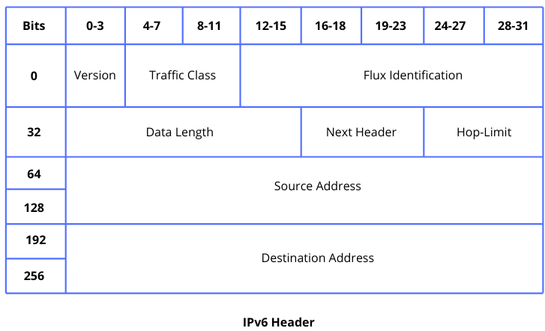

**(Datta, 2021)**

#### HTTP

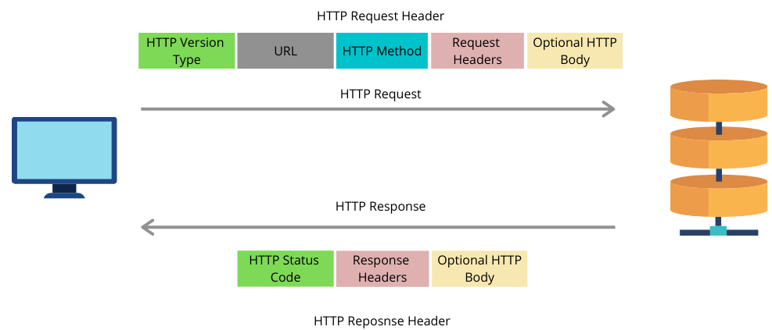The Hypertext Transfer Protocol (HTTP) is an application-level protocol for distributed, collaborative, hypermedia information systems. This is the foundation for data communication for the World Wide Web (i.e. internet) since 1990. HTTP is a generic and stateless protocol which can be used for other purposes as well using extensions of its request methods, error codes, and headers. **(Tutorialspoint, 2022)**

**(Datta, 2021)**

#### DNS

IP addresses are of numerical format and hence they are not easily readable or remember-able to humans. DNS is a hierarchical system that converts these IP addresses into a human-readable hostname. The most common vulnerability in DNS is cache poisoning. Here the attacker replaces the legitimate IP address to send the target audience to malicious websites. DNS amplification can also be exploited on a DNS server which permits recursive lookups and uses recursion to amplify the magnitude of the attack. **(Goyal, 2021)**

#### Ethernet

* Ethernet is a protocol made for [Local Area Networks (LAN)](https://en.wikipedia.org/wiki/Local_area_network). It was first standardized in 1983 as [IEEE 802.3](https://standards.ieee.org/standard/802_3-2018.html) and used with thick single coaxial cable 10BASE-5.
* The Ethernet 802.3 protocol defines [the physical layer](https://www.baeldung.com/cs/osi-model) in wired networking models, as well as the [medium access control (MAC)](https://en.wikipedia.org/wiki/Medium_access_control) sub-layer of the [data link layer](https://www.baeldung.com/cs/osi-model).
* There are several versions of the IEEE 802.3 protocol, e.g., 802.3a, 802.3i, 802.3j. Each version is designed to work on different types of cables. **(Datta, 2021)**
* Chart

  Description automatically generatedLet’s see the frame format of Ethernet 802.3 and Ethernet 802.11 protocols:

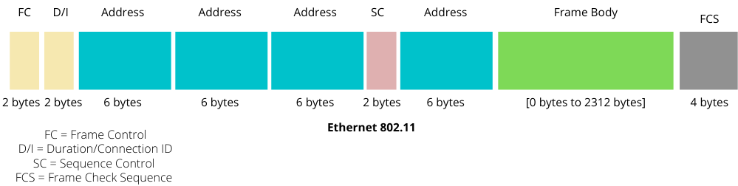

**(Datta, 2021)**

#### DHCP

The DHCP stands for **Dynamic Host Configuration Protocol**. It is a network management protocol used on IP networks. A DHCP server is used to assign an IP address and other configurations to the connected devices on the network to communicate with others. **(JavaTpoint, 2021)**

#### ICMP

The ICMP stands for Internet Control Message Protocol. It is a network layer protocol. It is used for error handling in the network layer, and it is primarily used on network devices such as routers. As different types of errors can exist in the network layer, so ICMP can be used to report these errors and to debug those errors.

**(JavaTpoint, 2021)**

#### ARP

Address Resolution Protocol (ARP) is a communication protocol used to find the MAC (Media Access Control) address of a device from its IP address. This protocol is used when a device wants to communicate with another device on a Local Area Network or Ethernet. **(JavaTpoint, 2021)**

#### UDP

The UDP stands for **User Datagram Protocol**. Its working is similar to the TCP as it is also used for sending and receiving the message. The main difference is that UDP is a connectionless protocol. Here, connectionless means that no connection establishes prior to communication. It also does not guarantee the delivery of data packets. It does not even care whether the data has been received on the receiver's end or not, so it is also known as the "fire-and-forget" protocol. It is also known as the **"fire-and-forget"** protocol as it sends the data and does not care whether the data is received or not. UDP is faster than TCP as it does not provide the assurance for the delivery of the packets. **(JavaTpoint, 2021)**

#### FTP

The File Transfer Protocol (FTP) is a standard network protocol provided by TCP/IP, and it is used to transfer files from one server to another. It is responsible for the reliably and efficient transfer of files.

Transferring a file from one server to another is simple, but several problems may arise. The sender system and the receiver server may have different file conventions or different ways to represent data. In some cases, the directory structures of two systems may differ from each other. FTP resolves all of these issues. **(Datta, 2021)**

## International standard organizations

### ISO

ISO is a nongovernmental organization that comprises standards bodies from more than 160 countries, with one standards body representing each member country.

**(Loshin, 2022)**

* Some of the standards used in the network:
* [**ISO/IEC 27000**](https://www.techtarget.com/whatis/definition/ISO-27001)**:** These security standards define a six-step process for developing and implementing information security policies and processes.
* [**ISO/IEC 17799**](https://www.techtarget.com/searchsoftwarequality/definition/ISO-IEC-17799)**:** This security management standard specifies more than 100 best practices for business continuity, access control, asset management and more.
* **ISO/IEC 20000:** This ISO standard creates a technical specification and codifies best practices for [IT service management](https://www.techtarget.com/searchitoperations/definition/ITSM).
* **ISO/IEC 12207:** This ISO standard creates a consistent [lifecycle management](https://www.techtarget.com/searchsoftwarequality/definition/application-lifecycle-management-ALM) process for all software.
* [**ISO 9000**](https://www.techtarget.com/searchdatacenter/definition/ISO-9000): This family of standards defines how organizations can establish and maintain effective quality assurance systems for manufacturing and service industries.

**(Loshin, 2022)**

### IEEE

It is US based professional organization of electronic, computer and communication engineering. It provides various set of rules and standard in communication and networking field. **(Guduruaishwarya09, 2021)**

Some standards are used in the network: IEEE 802, IEEE802.1, IEEE 802.2, IEEE802.3, IEEE802.4, IEEE804.5, and so on. **(Wikipedia, 2022)**

### W3C

The World Wide Web Consortium (W3C) is the main international [standards organization](https://en.wikipedia.org/wiki/Standards_organization) for the [World Wide Web](https://en.wikipedia.org/wiki/World_Wide_Web). Founded in 1994 and currently led by [Tim Berners-Lee](https://en.wikipedia.org/wiki/Tim_Berners-Lee), the [consortium](https://en.wikipedia.org/wiki/Consortium) is made up of member organizations that maintain full-time staff working together in the development of standards for the World Wide Web.

Some standards are used in the network: CSS, CGI, MathML, XML,  
SSML, HTML, RDF, and so on. **(Wikipedia, 2022)**

# Task 2 - Explain the impact of network topology, communication and bandwidth requirements (P2)

## Network topology

### Definition of network topology

A Network Topology is the arrangement with which computer systems or network devices are connected to each other. Topologies may define both physical and logical aspect of the network. Both logical and physical topologies could be same or different in a same network. **(Tutorialspoint, 2022)**

### Physical topology

Physical topology refers to the interconnected structure of a local area network (LAN). The method employed to connect the physical devices on the network with the cables, and the type of cabling used, all constitute the physical topology. This contrasts with logical topology, which describes a network's media signal performance and how it exchanges divice data. **(Techopedia, 2017)**

### Logical topology

A logical topology is a concept in networking that defines the architecture of the communication mechanism for all nodes in a network. Using network equipment such as routers and switches, the logical topology of a network can be dynamically maintained and reconfigured.

Logical topologies contrasts with physical topologies, which refer to the physical interconnections of all devices in the network. **(Techopedia, 2012)**

### The difference between physical topology and logical topology.

|  |  |
| --- | --- |
| **Physical Topology** | **Logical Topology** |
| Depicts physical layout of network. | Depicts logistics of network concerned with transmission of data. |
| The layout can be modified based on needs. | There is no interference and manipulation involved here. |
| It can be arranged in star, ring, mesh and bus topologies. | It exists in bus and ring topologies. |
| This has major impact on cost, scalability and bandwidth capacity of network based on selection and availability of devices. | This has major impact on speed and delivery of data packets. It also handles flow control and ordered delivery of data packets. |
| It is actual route concerned with transmission. | It is a high level representation of data flow. |
| Physical connection of the network. | Data path followed of the network. |

**(Yash, 2020)**

### Examples of popular topologies

#### Bus Topology

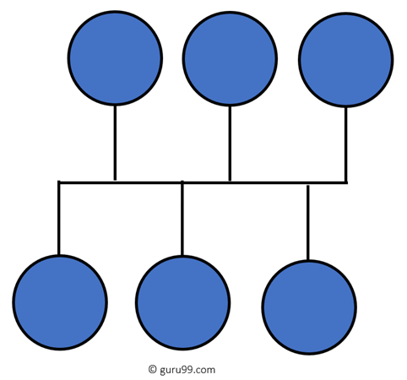Bus topology uses a single cable which connects all the included nodes. The main cable acts as a spine for the entire network. One of the computers in the network acts as the computer server. When it has two endpoints, it is known as a linear bus topology. **(Williams, 2022)**

**(Williams, 2022)**

* **Advantage**
* Cost of the cable is very less as compared to other topology, so it widely used to build small networks.
* Famous for Lan network because they are inexpensive and easy to install.
* It is widely used when a network in installation is small, simple, or temporary.
* It is one of the passive topologies. So computers on the bus only listen for data being sent, that are not responsible for moving the data form one computer to others. **(Williams, 2022)**
* **Disadvantage**
* In case if the common cable fails, then the entire system will crash down.
* When network traffic is heavy, it develops collisions in the network.
* Whenever network traffic is heavy, or nodes are too many, the performance time of the network significantly decreases.
* Cables are always of a limited length. **(Williams, 2022)**

#### Ring Topology

In a ring network, every device has exactly two neighboring devices for communication purpose. It is called a ring topology as its formation is like a ring. In this topology, every computer is connected to another computer. Here, the last node is combined with a first one.

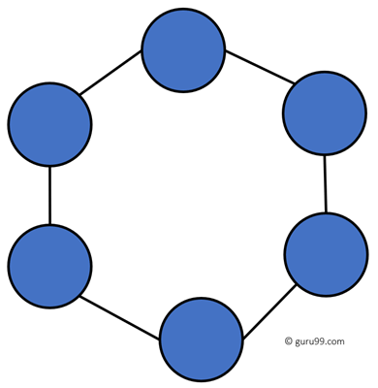This topology uses token to pass the information from one computer to another. In this topology, all the messages travel through a ring in the same direction. **(Williams, 2022)**

**(Williams, 2022)**

* **Advantage**
* Easy to install and reconfigure.
* Adding or deleting a device in-ring topology needs you to move only two connections.
* The troubleshooting process is difficult in a ring topology.
* Failure of one computer can disturb the whole network.
* Offers equal access to all the computers of the networks
* Faster error checking and acknowledgment.
* **Disadvantage**
* Unidirectional traffic.
* Break in a single ring can risk the breaking of the entire network
* Modern days high-speed LANs made this topology less popular.
* In the ring, topology signals are circulating at all times, which develops unwanted power consumption.
* It is very difficult to troubleshoot the ring network.
* Adding or removing the computers can disturb the network activity. **(Williams, 2022)**

#### Star Topology

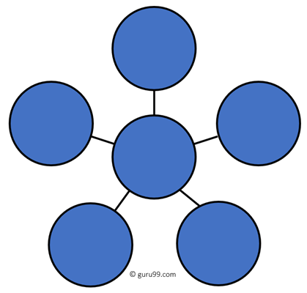In the star topology, all the computers connect with the help of a hub. This cable is called a central node, and all other nodes are connected using this central node. It is most popular on LAN networks as they are inexpensive and easy to install. **(Williams, 2022)**

**(Williams, 2022)**

* **Advantage**
* Easy to troubleshoot, set up, and modify.
* Only those nodes are affected, that has failed. Other nodes still work.
* Fast performance with few nodes and very low network traffic.
* In Star topology, addition, deletion, and moving of the devices are easy.

**(Williams, 2022)**

* **Disadvantage**
* If the hub or concentrator fails, attached nodes are disabled.
* Cost of installation of star topology is costly.
* Heavy network traffic can sometimes slow the bus considerably.
* Performance depends on the hub’s capacity
* A damaged cable or lack of proper termination may bring the network down. **(Williams, 2022)**

#### Mesh Topology

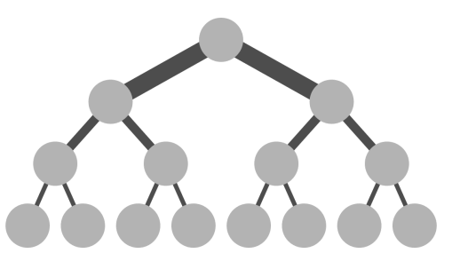Mesh topology is a type of networking in which all the computers are inter-connected to each other. In Mesh Topology, the connections between devices take place randomly. The connected nodes can be computers, switches, hubs, or any other devices. In this topology setup, even if one of the connections goes down, it allows other nodes to be distributed. This type of topology is very expensive and does not have any hierarchy, interdependency, and uniform pattern between nodes. The connections of the mesh topology are not easier to establish. **(JavaTpoint, 2021)**

**(JavaTpoint, 2021)**

* **Advantage**
* Failure during a single device won’t break the network.
* There is no traffic problem as there is a dedicated point to point links for every computer.
* Fault identification is straightforward.
* This topology provides multiple paths to succeed in the destination and tons of redundancy.
* It provides high privacy and security.
* Data transmission is more consistent because failure doesn’t disrupt its processes.
* Adding new devices won’t disrupt data transmissions.
* This topology has robust features to beat any situation.
* A mesh doesn’t have a centralized authority. **(Agarwal, 2020)**
* **Disadvantage**
* It’s costly as compared to the opposite network topologies i.e. star, bus, point to point topology.
* Installation is extremely difficult in the mesh.
* Power requirement is higher as all the nodes will need to remain active all the time and share the load.
* Complex process.
* The cost to implement mesh is above other selections.
* There is a high risk of redundant connections.
* Each node requires a further utility cost to think about.
* Maintenance needs are challenging with a mesh. **(Agarwal, 2020)**

#### Tree Topology

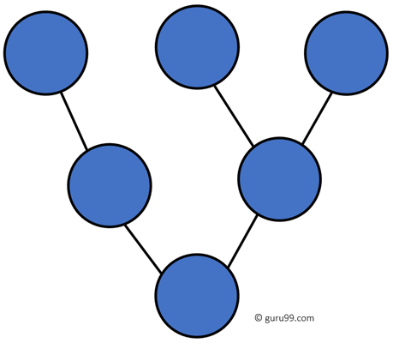A tree topology is a sort of structure in which each node is related to the others in a hierarchy. In a topological hierarchy, there are at least three distinct levels. Sometimes it is also called hierarchical topology as in this topology, all elements are arranged like the branches of a tree. It is a lot like the star and bus topologies. Tree topologies are commonly used to arrange data in databases and workstations in corporate networks. In a tree topology, any two linked nodes can only have one mutual connection, hence there can only be one link between them. **(JavaTpoint, 2021)**

**(Williams, 2022)**

* **Advantage**
* Failure of one node never affects the rest of the network.
* Node expansion is fast and easy.
* Detection of error is an easy process
* It is easy to manage and maintain
* **Disadvantage**
* It is heavily cabled topology
* If more nodes are added, then its maintenance is difficult
* If the hub or concentrator fails, attached nodes are also disabled. **(Williams, 2022)**

#### Hybrid Topology

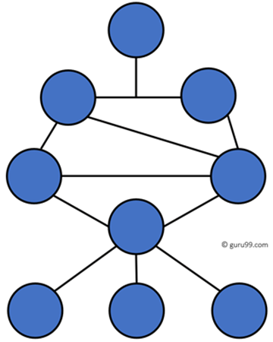A hybrid topology is a kind of network topology that is a combination of two or more network topologies, such as mesh topology, bus topology, and ring topology. Its usage and choice are dependent on its deployments and requirements like the performance of the desired network, and the number of computers, their location. The below figure is describing the structure of hybrid topology that contains more than one topology.

**(JavaTpoint, 2021)**

**(Williams, 2022)**

* **Advantage**
* This type of topology combines the benefits of different types of topologies in one topology.
* Can be modified as per requirement.
* It is extremely flexible.
* It is very reliable.
* It is easily scalable as Hybrid networks are built in a fashion which enables easy integration of new hardware components.
* Error detecting and troubleshooting are easy.
* Handles a large volume of traffic.
* It is used to create large networks.
* The speed of the topology becomes fast when two topologies are put together. **(Agarwal, 2022)**
* **Disadvantage**
* It is a type of network expensive.
* The design of a hybrid network is very complex.
* There is a change in the hardware to connect one topology with another topology.
* Usually, hybrid architectures are larger in scale so they require a lot of cables in the installation process.
* Hubs which are used to connect two distinct networks are very costly. And hubs are different from usual hubs as they need to be intelligent enough to work with different architectures.
* Installation is a difficult process. **(Agarwal, 2022)**

### Communication network

A communication network is a pattern or form that is implemented in the organization to communicate information effectively. The communication network is the established system where the message may flow in one or too many directions in the organization based on requirements. **(Tyonote, 2022)**

### The rules in the network

Before communicating with one another, individuals must use established rules or agreements to govern the conversation.

Notice how it is difficult to read the message because it is not formatted properly. It should be written using rules (i.e., protocols) that are necessary for effective communication.

Protocols must account for the following requirements to successfully deliver a message that is understood by the receiver:

* An identified sender and receiver
* Common language and grammar
* Speed and timing of delivery
* Confirmation or acknowledgment requirements **(CCNA, 2022)**

### Why are these rules needed?

Rules are an important component of data quality. When used in conjunction, network rules and [attribute rules](https://pro.arcgis.com/en/pro-app/3.0/help/data/geodatabases/overview/an-overview-of-attribute-rules.htm) help maintain data integrity.

Network rules dictate which network features can connect or associate in the utility network. These rules are imposed at the class level for specific asset groups and asset types. Features and objects can connect and associate as long as [feature restrictions](https://pro.arcgis.com/en/pro-app/3.0/help/data/utility-network/feature-restrictions.htm) are respected and network rules exist to allow such relationships.

All rules are evaluated when the network topology is enabled or validated. Rules are also evaluated when an association is created or imported.

There are several networks rules types:

* Junction-edge connectivity
* Junction-junction connectivity
* Edge-junction-edge connectivity
* Structural attachment
* Containment

**(Pro, n.d.)**

## Bandwidth requirements

Network bandwidth is a measurement indicating the maximum capacity of a wired or wireless communications link to transmit data over a network connection in a given amount of time. Typically, bandwidth is represented in the number of bits, kilobits, megabits or gigabits that can be transmitted in 1 second. Synonymous with capacity, bandwidth describes [data transfer rate](https://www.techtarget.com/searchunifiedcommunications/definition/data-transfer-rate). Bandwidth is not a measure of network speed -- a common misconception. **(Froehlich, 2021)**

### Why is bandwidth requirement needed for networks?

Bandwidth is [not an unlimited resource](https://www.theserverside.com/tip/Limited-bandwidth-may-stifle-IoT-development). In any given deployment location, such as a home or business, there is only so much capacity available. Sometimes, this is due to physical limitations of the network device, such as the router or modem, cabling or wireless frequencies being used. Other times, bandwidth is intentionally rate-limited by a network administrator or internet or wide area network (WAN) carrier.

Multiple devices using the same connection must share bandwidth. Some devices, such as TVs that stream 4K video, are bandwidth hogs. In comparison, a webinar typically uses far less bandwidth. Although speed and bandwidth are not interchangeable, greater bandwidth is essential to maintain tolerable speeds on multiple devices. **(Froehlich, 2021)**

# Task 3 - Discuss the operating principles of networking devices and server types (P3)

## How some devices work in the network?

### Switches

Switches are networking devices operating at layer 2 or a data link layer of the OSI model. They connect devices in a network and use packet switching to send, receive or forward data packets or data frames over the network.

A switch has many ports, to which computers are plugged in. When a data frame arrives at any port of a network switch, it examines the destination address, performs necessary checks and sends the frame to the corresponding device(s).It supports unicast, multicast as well as broadcast communications. **(Moumita, 2020)**

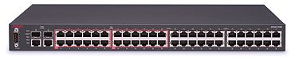

**(Wikipedia, 2022)**

### Router

A router analyzes a destination IP address of a given packet header and compares it with the routing table to decide the packet's next path. The list of routing tables provides directions to transfer the data to a particular network destination. They have a set of rules that compute the best path to forward the data to the given IP address.

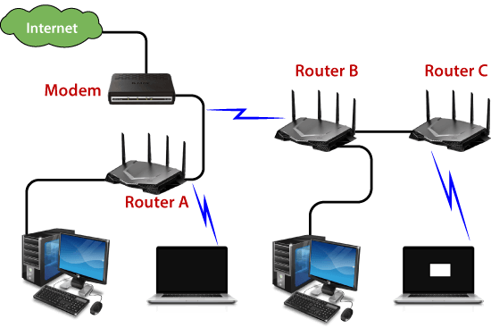Routers use a modem such as a cable, fiber, or DSL modem to allow communication between other devices and the internet. Most of the routers have several ports to connect different devices to the internet at the same time. It uses the routing tables to determine where to send data and from where the traffic is coming.

A routing table mainly defines the default path used by the router. So, it may fail to find the best way to forward the data for a given packet. For example, the office router along a single default path instructs all networks to its internet services provider.

**(JavaTpoint, 2021)**

## Some other common networking devices

### Gateway

A physical network gateway includes network interface cards (NICs) and inputs and outputs—usually Ethernet—and software for translating network protocols. Gateway functions may also be defined, deployed, and controlled through software, and are increasingly being built into routers and other equipment.

A gateway is typically used on the network layer of the Open Systems Interconnection (OSI) model, but it could theoretically be deployed on any of the OSI layers. Standalone or virtual gateways may be placed anywhere in a network where translation is needed. They can be unidirectional (allowing data to flow in only one direction) or bidirectional (allowing data to flow both in and out of a network).

As an entry or exit point for data, a gateway can be used in a variety of security processes, such as a firewall to scan and filter data or a proxy server to maintain restricted access to certain applications or assets. **(Cisco, n.d.)**

### Firewall

A Firewall is a necessary part of any security architecture and takes the guesswork out of host level protections and entrusts them to your network security device. Firewalls, and especially Next Generation Firewalls, focus on blocking malware and application-layer attacks, along with an integrated intrusion prevention system (IPS), these Next Generation Firewalls can react quickly and seamlessly to detect and react to outside attacks across the whole network. They can set policies to better defend your network and carry out quick assessments to detect invasive or suspicious activity, like malware, and shut it down. **(Point, n.d.)**

### Access point

Access points work by connecting direct to your broadband router or network switch with a Ethernet or data cable. This provides the AP with the internet connection and bandwidth required. It then transmits and receives a wireless signal in either the 2.4Ghz or 5Ghz frequency range (WIFI).This allows you to connect wireless to your Local Area Network (LAN) and the internet.

Wireless Access points are perfect for devices where you cannot connect a physical Ethernet cable or where it would be difficult to do so, making them perfect for providing an internet connection to Smart phones,Tablets, Laptops, Wireless Audio Systems, Smart TV’s and so on. I personally work on the philosophy of “wires for the things that don’t move, wireless for things that do.” This means that for the best, fastest and most secure connection a dedicated Ethernet cable would be the best way to go for your PC’sand Smart TV’s etc, but obviously this may mean drilling holes in walls and lifting floorboards to install some Category 5 so a good wireless connection would be the next best solution. **(Tom, 2022)**

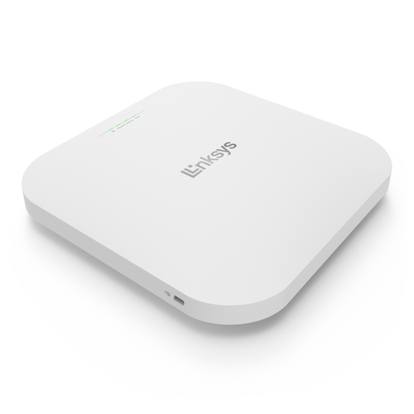

**(Linksys, n.d.)**

## Some common types of servers

### DNS sever

The domain name system (DNS) is a naming database in which internet [domain](https://www.techtarget.com/whatis/definition/domain) names are located and translated into [Internet Protocol (IP) addresses](https://www.techtarget.com/whatis/definition/IP-address-Internet-Protocol-Address). The domain name system maps the name people use to locate a website to the IP address that a computer uses to locate that website. **(Lutkevich, 2021)**

* **Advantages of DNS**

**1. Internet Dependency**

Internet has become an important aspect of our daily life such that people and companies cannot carry out their works without internet. DNS makes it easier to use the internet by remembering all the IP addresses. In fact without DNS, internet would simply not exist.

**2. Internet Speed**

One of the key features in DNS is that it can offer high speed connections. Individuals and organizations mostly take use of this speed.

**3. Security**

Some DNS servers are specifically designed for security purposes such that it has become an important component for your home or work connections. Whenever hackers try to hack the servers, their attempts are prevented gaining access into your systems. However if it is a large organization with lots of sensitive informations, you need other security measures as well.

**4. IP Address Conversion**

DNS allows users to categorize and archive search terms without needing to remember IP addresses. All the domains are converted into IP addresses when the name is given to the search engines. Therefore, you don't need to memorize IP address for each and every site that you access frequently.

**5. Stability**

For some reasons the IP address of websites may change. So users are in need to keep up to date of this information too. This can be very laborious task. But for facilitating this, DNS system constantly updates IP address so that users can avoid important efforts. (Roomi, 2020)

* **Disadvantages of DNS**

**1. Registry Control**

Registry control of DNS is under ICANN. Which means that no other organizations will be able to control them. Hence, the concept of net neutrality is questioned here. ICANN is known as a non-profit organization which originates from one single country.

**2. Client Informations**

Informations about the client who started the name resolution do not normally get carried by the DNS queries. Due to this the server side will be able to know the IP address of DNS servers. It can be manipulated by hackers.

**3. Server Breakdown**

When the DNS server gets broken down, the World Wide Web would crash too. Al though in the presence of back up servers and root servers. This is because once the server crashes the connection to the local network will get disconnected not allowing the clients to reach them.

**4. DNS Attacks**

One of the major problems that DNS undergoes is the DNS attack. In here the original DNS address is replaced with a fake one so that users are redirected into fraudulent websites. From this attackers can gather sensitive informations such as band account details.

**5. Troubleshooting**

DNS issues are generally difficult to troubleshoot. This is due to its distributed nature and geographical locations. **(Roomi, 2020)**

* **Example**

For example, if someone types "example.com" into a web browser, a server behind the scenes maps that name to the corresponding IP address. An IP address is similar in structure to 203.0.113.72. **(Lutkevich, 2021)**

### Web sever

Web server is a program which processes the network requests of the users and serves them with files that create web pages. This exchange takes place using Hypertext Transfer Protocol (HTTP). **(Gupta, 2019)**

* **Example:**

Basically, web servers are computers used to store HTTP files which makes a website and when a client requests a certain website, it delivers the requested website to the client. For example, you want to open Facebook on your laptop and enter the URL in the search bar of google. Now, the laptop will send an HTTP request to view the facebook webpage to another computer known as the webserver. This computer (webserver) contains all the files (usually in HTTP format) which make up the website like text, images, gif files, etc. After processing the request, the webserver will send the requested website-related files to your computer and then you can reach the website. **(Gupta, 2019)**

### FPT sever

File transfer protocol (FTP) is an Internet tool provided by TCP/IP. The first feature of FTP is developed by Abhay Bhushan in 1971. It helps to transfer files from one computer to another by providing access to directories or folders on remote computers and allows software, data, text file to be transferred between different kinds of computers. The end-user in the connection is known as localhost and the server which provides data is known as the remote host.  **(Deepika, 2021)**

* **Advantages**
* **Multiple transfers:** FTP helps to transfer multiple large files in between the systems.
* **Efficiency:**FTP helps to organize files in an efficient manner and transfer them efficiently over the network.
* **Security:** FTP provides access to any user only through user ID and password. Moreover, the server can create multiple levels of access.
* **Continuous transfer:** If the transfer of the file is interrupted by any means, then the user can resume the file transfer whenever the connection is established.
* **Simple:**FTP is very simple to implement and use, thus it is a widely used connection.
* **Speed:** It is the fastest way to transfer files from one computer to another.

**(Deepika, 2021)**

* **Disadvantages**
* **Less security:** FTP does not provide an encryption facility when transferring files. Moreover, the username and passwords are in plain text and not a combination of symbols, digits, and alphabets, which makes it easier to be attacked by hackers.
* **Old technology:**FTP is one of the oldest protocols and thus it uses multiple TCP/IP connections to transfer files. These connections are hindered by firewalls.
* **Virus:**The FTP connection is difficult to be scanned for viruses, which again increases the risk of vulnerability.
* **Limited:**The FTP provides very limited user permission and mobile device access.
* **Memory and programming:** FTP requires more memory and programming efforts, as it is very difficult to find errors without the commands. **(Deepika, 2021)**
* **Example:**

FTP software is relatively straightforward to set up. FileZilla is a free, downloadable FTP client. Type in the address of the server you wish to access, the port, and the password for accessing the server.

Once access has been granted, the user's files on their local system as well as the accessed server will be visible. The user can download files from the server to the local system, or upload files from the local system to the server. They can also make changes to files on the server, as long as they have the proper authorization to do so. **(Mitchell, 2021)**

# Task 4 - Discuss the inter-dependence of workstation hardware with relevant networking software (P4)

## What does Interdependence mean?

Interdependence is a connection between subjects where one subject’s needs can be fulfilled by the other subject’s resources and these transfer of resources works both ways. That means both subjects need each other to fulfill their needs. These kinds of relationships can be found almost everywhere since, as humans, we need other people’s help to survive and strive. In the business field, organizations depend on each other in many different levels.

Depending on the nature of the relationship, the degree of interdependence can be so high that the disappearance of one party might cause the other party to disappear too. Interdependence can be found in client-supplier relationships when it comes to raw materials. The supplier needs the client to pay for his goods but the client also needs the supplier in order to produce its own goods.

On the other hand, there’s also interdependence between business and financial companies. The latter needs to loan money to be financially profitable and the former needs to borrow money to leverage itself in order to grow. **(Course, 2022)**

* **Example:**

A business called City Wheels Co. is a bike rental venture that serves the city of Los Angeles. The company leases bikes to individuals for given periods of time and they have locations all around the city to pick-up and deliver the bikes. From the perspective of interdependence we can identify at least two essential interdependent relationships between the business and other parties.

First of all, City Wheels and its clients are interdependent since these individuals need the bikes for transportation and the company also depends on them to earn the revenues they need to remain operational. And second of all, there’s also interdependence with bike mechanics and bike suppliers, since in both cases these suppliers depend on the company to keep their business running and City Wheels depends on them to keep its business well equipped to serve its clients. **(Course, 2022)**

## Workstation hardware

A workstation (WS) is a computer dedicated to a user or group of users engaged in business or professional work. It includes one or more high resolution displays and a faster processor than a personal computer (PC). A workstation also has greater multitasking capability because of additional random access memory (RAM), drives and drive capacity. A workstation may also have a higher-speed graphics adapters and more connected peripherals.

The term workstation also has been used to reference a PC or mainframe terminal on a local area network (LAN). These workstations may share network resources with one or more large client computers and network servers. **(Techopedia, 2012)**

* **Example:**

1. Keyboard
2. Mouse
3. Printer
4. Speakers
5. Headphones
6. Random Access Memory (RAM)
7. Hard Disk Drive (HDD)
8. Video Card
9. Solid-State Drive (SSD) **(Goodman, 2022)**

## Networking software

Network software is a fundamental element for any networking system. It helps administrators and security personnel reduce network complexities, and manage, monitor, and better control network traffic. Network software plays a crucial role in managing a network infrastructure and simplifying IT operations by facilitating communication, security, content, and data sharing.

Network software offers useful benefits to organizations. It has become an important tool in facilitating round-the-clock communication and allowing an uninterrupted exchange of information. One of the most significant advantages of network software is its direct correlation with productivity. The centralized nature of network software increases the productivity of the complete system. This helps reduce end-user technical support problems.

For example, if an end user accidentally damages their computer, the chances of losing data are reduced substantially as all its data is already shared on the network. Another key benefit of network software is its ability to enable programmatic management of network resources. This eliminates the need for manual processes, thereby providing a dynamic and efficient network configuration to work with. **(Mohanakrishnan, 2022)**

* **Example:**

Since personal computers have become ubiquitous in many countries, computer software can be found across the globe. In fact, because of the widespread use of computers in both personal and business contexts, as well as the integral role that the internet plays in the global economy, it is difficult to imagine how today's world would function without computer software. A list of some of the most well-known computer software examples includes:

* Operating systems (such as Microsoft Windows, Linux, macOS)
* Productivity Software (for example, Microsoft Office Suite including Word, Excel, and PowerPoint)
* Internet Browsers (including Firefox, Chrome, and Safari)

These and other specific examples of computer software are used many times per day by individuals and companies around the world**. (Hauser, 2021)**

## The interdependence of workstation hardware and network software:

Hardware and software are mutually dependent on each other in terms of their relationship. Computers can only produce useful outputs when both of them work together. Hardware is required for the use of software. In a software, the user interacts with the hardware in a way that is similar to how they do on a computer.

It is not unusual for hardware and software to be interdependent. It is expected that each of them will work together to produce a useful output for the computer. In order for the software to work, there must be a support for any hardware device. When there is no proper instruction, the hardware cannot be used and is useless.

It is not possible to do anything without the help of hardware and software. Computers can only produce useful outputs when both of them work together. In a software, the user interacts with the hardware in a way that is similar to how they do on a computer. Computers are ‘hearts’ of their hardware, and their software is their soul.

**(Morales, 2021)**

# References

Agarwal, P., 2020. *GeeksforGeeks.* [Online]   
Available at: <https://www.geeksforgeeks.org/advantage-and-disadvantage-of-mesh-topology/>

Agarwal, P., 2022. *GeeksforGeeks.* [Online]   
Available at: <https://www.geeksforgeeks.org/advantages-and-disadvantages-of-hybrid-topology/>

CCNA, 2022. *CCNA.* [Online]   
Available at: [https://ccna-200-301.online/the-rules/#Rule_Establishment](https://ccna-200-301.online/the-rules/%23Rule_Establishment)

Cisco, n.d. *Cisco.* [Online]   
Available at: <https://www.cisco.com/c/en/us/products/routers/what-is-a-network-gateway.html>

CompTIA, 2021. *comptia.* [Online]   
Available at: <https://www.comptia.org/content/guides/what-is-a-network-protocol>

Course, M. A., 2022. *myaccountingcourse.* [Online]   
Available at: <https://www.myaccountingcourse.com/accounting-dictionary/interdependence>

Datta, S., 2021. *Baeldung.* [Online]   
Available at: <https://www.baeldung.com/cs/popular-network-protocols>

Deepika, 2021. *GeeksforGeeks.* [Online]   
Available at: <https://www.geeksforgeeks.org/file-transfer-protocol-ftp/?ref=gcse>

Froehlich, A., 2021. *TechTarget.* [Online]   
Available at: <https://www.techtarget.com/searchnetworking/definition/bandwidth>

Goodman, P., 2022. *TurboFuture.* [Online]   
Available at: <https://turbofuture.com/computers/Computer-Basics-Examples-of-Hardware>

Goyal, A., 2021. *GeeksforGeeks.* [Online]   
Available at: <https://www.geeksforgeeks.org/types-of-area-networks-lan-man-and-wan/>

Guduruaishwarya09, 2021. *GeeksforGeeks.* [Online]   
Available at: <https://www.geeksforgeeks.org/introduction-of-ieee-1901-2a/?ref=gcse>

Gupta, V., 2019. *GeeksforGeeks.* [Online]   
Available at: <https://www.geeksforgeeks.org/web-server-and-its-type/?ref=gcse>

Hauser, P., 2021. *Study.* [Online]   
Available at: <https://study.com/learn/lesson/computer-software-examples-types.html>

JavaTpoint, 2021. *javaTpoint.* [Online]   
Available at: <https://www.javatpoint.com/what-is-mesh-topology>

JavaTpoint, 2021. *javaTpoint.* [Online]   
Available at: <https://www.javatpoint.com/types-of-computer-network>

JavaTpoint, 2021. *javaTpoint.* [Online]   
Available at: <https://www.javatpoint.com/what-is-tree-topology>

JavaTpoint, 2021. *javaTpoint.* [Online]   
Available at: <https://www.javatpoint.com/dhcp>

JavaTpoint, 2021. *javaTpoint.* [Online]   
Available at: [https://www.javatpoint.com/icmp-protocol](https://www.linksys.com/what-is-a-wifi-access-point.html)

JavaTpoint, 2021. *javaTpoint.* [Online]   
Available at: [https://www.javatpoint.com/address-resolution-protocol-and-its-types](https://www.linksys.com/what-is-a-wifi-access-point.html)

JavaTpoint, 2021. *javaTpoint.* [Online]   
Available at: [https://www.javatpoint.com/tcp-vs-udp](https://www.linksys.com/what-is-a-wifi-access-point.html)

JavaTpoint, 2021. *javaTpoint.* [Online]   
Available at: <https://www.javatpoint.com/what-is-hybrid-topology>

JavaTpoint, 2021. *javaTpoint.* [Online]   
Available at: <https://www.javatpoint.com/router>

Linksys, n.d. *linksys.* [Online]   
Available at: <https://www.linksys.com/what-is-a-wifi-access-point.html>

Loshin, P., 2022. *TechTarget.* [Online]   
Available at: [https://www.techtarget.com/searchdatacenter/definition/ISO#:~:text=ISO%20(International%20Organization%20for%20Standardization)%20is%20a%20worldwide%20federation%20of,body%20representing%20each%20member%20country](https://www.techtarget.com/searchdatacenter/definition/ISO%23:~:text=ISO%20(International%20Organization%20for%20Standardization)%20is%20a%20worldwide%20federation%20of,body%20representing%20each%20member%20country)

Lutkevich, B., 2021. *TechTarget.* [Online]   
Available at: <https://www.techtarget.com/searchnetworking/definition/domain-name-system>

Mitchell, C., 2021. *Investopedia.* [Online]   
Available at: [https://www.investopedia.com/terms/f/ftp-file-transfer-protocol.asp#:~:text=Examples%20of%20FTP%20clients%20that,Free%20FTP%2C%20and%20Core%20FTP.](https://www.investopedia.com/terms/f/ftp-file-transfer-protocol.asp%23:~:text=Examples%20of%20FTP%20clients%20that,Free%20FTP%2C%20and%20Core%20FTP.)

Mohanakrishnan, R., 2022. *spiceworks.* [Online]   
Available at: <https://www.spiceworks.com/tech/networking/articles/what-is-network-software/>

Morales, 2021. *lemp.* [Online]   
Available at: [https://lemp.io/why-workstation-hardware-interdependent-to-networking-operating-system/#6](https://lemp.io/why-workstation-hardware-interdependent-to-networking-operating-system/%236)

Morales, 2021. *lemp.* [Online]   
Available at: [https://lemp.io/why-workstation-hardware-interdependent-to-networking-operating-system/#4](https://lemp.io/why-workstation-hardware-interdependent-to-networking-operating-system/%234)

Moumita, 2020. *tutorialspoint.* [Online]   
Available at: [https://www.tutorialspoint.com/what-are-switches-in-computer-network#:~:text=Switches%20are%20networking%20devices%20operating,which%20computers%20are%20plugged%20in.](https://www.tutorialspoint.com/what-are-switches-in-computer-network%23:~:text=Switches%20are%20networking%20devices%20operating,which%20computers%20are%20plugged%20in.)

Point, C., n.d. *checkpoint.* [Online]   
Available at: <https://www.checkpoint.com/cyber-hub/network-security/what-is-firewall/>

Pro, A., n.d. *ArcGIS Pro.* [Online]   
Available at: <https://pro.arcgis.com/en/pro-app/latest/help/data/utility-network/network-rules.htm>

Roomi, M., 2020. *hitechwhizz.* [Online]   
Available at: <https://www.hitechwhizz.com/2020/09/5-advantages-and-disadvantages-drawbacks-benefits-of-dns.html>

Satyabrata_Jena, 2022. *GeeksforGeeks.* [Online]   
Available at: <https://www.geeksforgeeks.org/overview-of-personal-area-network-pan/>

Techopedia, 2012. *techopedia.* [Online]   
Available at: [https://www.techopedia.com/definition/25890/logical-topology#:~:text=A%20logical%20topology%20is%20a,be%20dynamically%20maintained%20and%20reconfigured.](https://www.techopedia.com/definition/25890/logical-topology%23:~:text=A%20logical%20topology%20is%20a,be%20dynamically%20maintained%20and%20reconfigured.)

Techopedia, 2012. *techopedia.* [Online]   
Available at: <https://www.techopedia.com/definition/5140/workstation-ws>

Techopedia, 2017. *techopedia.* [Online]   
Available at: <https://www.techopedia.com/definition/4794/physical-topology>

Tom, 2022. *Smart Aerials.* [Online]   
Available at: [https://www.smartaerials.co.uk/blog/wireless-access-points-what-they-do-how-they-work#:~:text=Access%20points%20work%20by%20connecting,5Ghz%20frequency%20range%20(WIFI).](https://www.smartaerials.co.uk/blog/wireless-access-points-what-they-do-how-they-work%23:~:text=Access%20points%20work%20by%20connecting,5Ghz%20frequency%20range%20(WIFI).)

Tutorialspoint, 2022. *tutorialspoint.* [Online]   
Available at: <https://www.tutorialspoint.com/http/http_overview.htm>

Tutorialspoint, 2022. *tutorialspoint.* [Online]   
Available at: <https://www.tutorialspoint.com/data_communication_computer_network/computer_network_topologies.htm>

Tyonote, 2022. *tyonote.* [Online]   
Available at: <https://tyonote.com/communication_network/>

Wikipedia, 2022. *wikipedia.* [Online]   
Available at: <https://en.wikipedia.org/wiki/Institute_of_Electrical_and_Electronics_Engineers>

Wikipedia, 2022. *wikipedia.* [Online]   
Available at: <https://en.wikipedia.org/wiki/World_Wide_Web_Consortium>

Wikipedia, 2022. *Wikipedia.* [Online]   
Available at: <https://en.wikipedia.org/wiki/Switch>

Williams, L., 2022. *Guru99.* [Online]   
Available at: <https://www.guru99.com/types-of-computer-network.html>

Williams, L., 2022. *Guru99.* [Online]   
Available at: [https://www.guru99.com/type-of-network-topology.html#5](https://www.guru99.com/type-of-network-topology.html%235)

Yash, 2020. *GeeksforGeek.* [Online]   
Available at: <https://www.geeksforgeeks.org/difference-between-physical-and-logical-topology/>